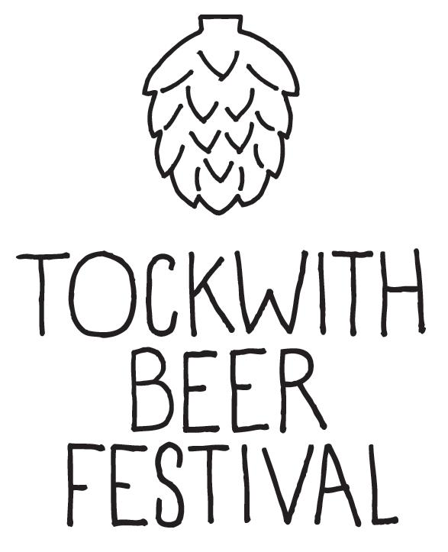

Application for Donation
Tockwith Festivals Ltd
Registered Charity 1143871
Our Charity’s Objective:
To further such purposes as are exclusively charitable according to the laws of England and Wales as the trustees may from time to time determine for the benefit of the communities of Tockwith and surrounding area by funds raised by Tockwith Festivals.

Please provide us with as much information as possible. All questions are mandatory (except website); if a question doesn’t apply to your organisation please state non applicable.
Section 1: Details of the organisation requested a donation
Organisation name
Contact details
Name
Address
Telephone
Email
Website

Section 2: Profile of the organisation
Please provide details of the purpose of the organisation.
Is the organisation a registered charity?
If so what is the registration number?
How does the organisation support the communities of Tockwith and surrounding areas? Please give specific examples.
Is the environment an important consideration for your organisation when making decisions? Please give examples.
How long has your organisation been established?
Is your organisation a not for profit organisation? (We are unable to provide a donation to organisations that do not reinvest all its surpluses into the community).
Does anyone in your organisation draw a salary or take any other personal benefit from your organisation?
Do you prepare annual financial reports?
If so are you happy to provide a copy of them to us? (If yes, please attach them to this application)

Section 3: Details of your request for a donation
According to Charity Commission regulations we are only able to award donations for specific projects that benefit the communities of Tockwith and the surrounding areas. We cannot provide general donations to other organisations / charities.
Please describe the specific project for which you are requesting a donation - include timescales (short and long term goals). The charity is unable to provide donations for general expenditure. Please attach any additional information, such as quotes / costings / minutes of meetings etc.

Please provide details of how this will benefit the communities, including the age group this project will provide for.

Please provide details of the positive environmental impacts this project will have.

How much is the cost of the entire project?

What is the amount of the donation you are requesting?

Please give details of what other methods of fundraising the organisation is undertaking. It is expected that any donation awarded will only cover part of the overall project and we may ask for further evidence of how you will be raising funds.

When will you require the donation? Please note we will commit our support to a project but only release funds on completion of the project or against invoices relating to the project.

Please add any other comments that you feel would be helpful in reviewing the organisation's application for a donation. You may attach any relevant copies of documents or information that you feel may be relevant to application.

If you have any queries regarding your application or wish to monitor its progress in the future please contact info@tockwithfestivals.co.uk and we will aim to respond within 7 working days of your enquiry.
All donation applications will be considered fully by the Tockwith Festivals Donation Panel in accordance with the Tockwith Festivals charitable purpose outlined above and the Tockwith Festivals Donation Application Policy.

